**Practical Assignment**

**Objective: - Predict Next Sequence**

To start with deep learning, the very basic project that you can build is to predict the next digit in a sequence.

**Dataset: -** Create a sequence like a list of odd numbers and then build a model and train it to predict the next digit in the sequence.

**Task: -** A simple neural network with 2 layers would be sufficient to build the model.

**Assignment Submission: -** Only submit the Google Colab/Github link.(Make the Link Public).

**Practical Assignment**

**Objective: - Image Classification with Indoor Scenes Images**

From MIT, this dataset contains over 15,000 images of indoor locations. The dataset was originally built to tackle the problem of indoor scene recognition. All images are in JPEG format and have been divided into 67 categories. The number of images per category vary. However, there are at least 100 images for each category.

**Dataset Link: -**

[**https://www.kaggle.com/itsahmad/indoor-scenes-cvpr-2019**](https://www.kaggle.com/itsahmad/indoor-scenes-cvpr-2019)

**Task: -** Create a Web Application using Flask. Use the end user should be able to upload an image and get results with the prediction score. Use any CNN architecture launched after 2014.

**Deployment: -** Any Free Platform(Try to look out for free options.)

**Assignment Submission: -** Only submit the hosted app link.

**Practical Assignment**

**Objective: - Image Classification with Indoor Scenes Images**

Created by Intel for an image classification contest, this expansive image dataset contains approximately 25,000 images. Furthermore, the images are divided into the following categories: buildings, forest, glacier, mountain, sea, and street. The dataset has been divided into folders for training, testing, and prediction. The training folder includes around 14,000 images and the testing folder has around 3,000 images. Finally, the prediction folder includes around 7,000 images.

**Dataset Link: -**

[**https://www.kaggle.com/puneet6060/intel-image-classification/version/2**](https://www.kaggle.com/puneet6060/intel-image-classification/version/2)

**Task: -** Create a Web Application using Flask. Use the end user should be able to upload an image and get results with the prediction score. Use any CNN architecture launched after 2015.

**Deployment: -** Any Free Platform(Try to look out for free options.)

**Assignment Submission: -** Only submit the hosted app link.

**Practical Assignment**

**Objective: - Image Classification with Tiny ImageNet**

Stanford prepared the Tiny ImageNet dataset for their CS231ncourse. The dataset spans 200 image classes with 500 training examples per class. The dataset also has 50 validation and 50 test examples per class. The images are down-sampled to 64x64 pixels vs. 256x256 for the original ImageNet. The full ImageNet dataset also has 1000 classes. Tiny ImageNet is large enough to be a challenging and realistic problem. But not so big as to require days of training before you see results.

**Dataset Link: -**

[**http://cs231n.stanford.edu/tiny-imagenet-200.zip**](http://cs231n.stanford.edu/tiny-imagenet-200.zip)

**Task: -** Create a Web Application using Flask. Use the end user should be able to upload an image and get results with the prediction score. Use any CNN architecture launched after 2016.

**Deployment: -** Any Free Platform(Try to look out for free options.)

**Assignment Submission: -** Only submit the hosted app link.

**Practical Assignment**

**Objective: - Object Detection with Oxford-IIIT Pet Dataset**

Stanford with IIIT have created a 37 category pet dataset with roughly 200 images for each class. The images have a large variations in scale, pose and lighting. All images have an associated ground truth annotation of breed, head ROI, and pixel level trimap segmentation.

**Dataset Link: -**

**Dataset :-** [**https://www.robots.ox.ac.uk/~vgg/data/pets/data/images.tar.gz**](https://www.robots.ox.ac.uk/~vgg/data/pets/data/images.tar.gz)

**Ground Truth :-** [**https://www.robots.ox.ac.uk/~vgg/data/pets/data/annotations.tar.gz**](https://www.robots.ox.ac.uk/~vgg/data/pets/data/annotations.tar.gz)

**Task: -** Create a Web Application using Flask. Use the end user should be able to upload an image and get results with the prediction score. Use any CNN architecture launched after 2017.

**Deployment: -** Any Free Platform(Try to look out for free options.)

**Assignment Submission: -** Only submit the hosted app link. OR GitHub Link

**Practical Assignment**

**Objective: - Object Detection with OpenImages**

Open Images is a new dataset first released in 2016 that contains ~9 million images – which is fewer than ImageNet. What makes it stand out is that these images are mostly of complex scenes that span thousands of classes of objects. Moreover, ~2 million of these images are hand-annotated with bounding boxes making Open Images by far the largest existing dataset with object location annotations. In this subset of images, there are ~15.4 million bounding boxes of 600 classes of object.

**Dataset Link: -** Dataset is pretty big. SO we do not want to train it completely. So please extract any 10 classes images and annotations that you like. Then train it.

Link :- <https://github.com/cvdfoundation/open-images-dataset>

**Task: -** Create a Web Application using Flask. Use the end user should be able to upload an image and get results with the prediction score. Use any CNN architecture launched after 2017.

**Deployment: -** Any Free Platform(Try to look out for free options.)

**Assignment Submission: -** Only submit the hosted app link. OR GitHub Link

**Practical Assignment**

**Objective: - Object Detection with MSCOCO**

Microsoft is in this game also with their Common Objects in Context (COCO) dataset. Containing ~200K images, it’s relatively small but what makes it stand out are its challenges that come associated with the additional features it provides for each image.

COCO challenges are also held annually. But each year’s challenge is slightly different. This year the challenge has four tracks:

1. Object segmentation
2. Panoptic segmentation
3. Keypoint detection
4. DensePose task

**Dataset Link: -** Dataset is pretty big. SO we do not want to train it completely. So please extract any 10 classes images and annotations that you like. Then train it.

Link :- <https://cocodataset.org/#download>

**Task: -** Create a Web Application using Flask. Use the end user should be able to upload an image and get results with the prediction score. Use any CNN architecture launched after 2017.

**Deployment: -** Any Free Platform(Try to look out for free options.)

**Assignment Submission: -** Only submit the hosted app link. OR GitHub Link

**Practical Assignment**

**Objective: - Object Detection with DeepFashion2**

DeepFashion2 is a comprehensive fashion dataset. It contains 491K diverse images of 13 popular clothing categories from both commercial shopping stores and consumers. It totally has 801K clothing clothing items, where each item in an image is labeled with scale, occlusion, zoom-in, viewpoint, category, style, bounding box, dense landmarks and per-pixel mask.There are also 873K Commercial-Consumer clothes pairs.

**Dataset Link: -**

Link :- <https://drive.google.com/drive/folders/125F48fsMBz2EF0Cpqk6aaHet5VH399Ok>

Github :- <https://github.com/switchablenorms/DeepFashion2>

**Task: -** Create a Web Application using FASTAPI. Use the end user should be able to upload an image and get results with the prediction score, class name and bounding box co ordinates. Use any CNN architecture launched after 2018.

**Deployment: -** Any Free Platform(Try to look out for free options.)

**Assignment Submission: -** Only submit the hosted app link. OR GitHub Link

**Practical Assignment**

**Objective: - Instance Segmentation with DeepFashion2**

DeepFashion2 is a comprehensive fashion dataset. It contains 491K diverse images of 13 popular clothing categories from both commercial shopping stores and consumers. It totally has 801K clothing clothing items, where each item in an image is labeled with scale, occlusion, zoom-in, viewpoint, category, style, bounding box, dense landmarks and per-pixel mask.There are also 873K Commercial-Consumer clothes pairs.

**Dataset Link: -**

Link :- <https://drive.google.com/drive/folders/125F48fsMBz2EF0Cpqk6aaHet5VH399Ok>

Github :- <https://github.com/switchablenorms/DeepFashion2>

**Task: -** Create a Web Application using FASTAPI. Use the end user should be able to upload an image and get results with the prediction score, class name and bounding box co ordinates. Use any CNN architecture launched after 2018.

**Deployment: -** Any Free Platform(Try to look out for free options.)

**Assignment Submission: -** Only submit the hosted app link. OR GitHub Link

**Practical Assignment**

**Objective: - Human Face Detection System**

The face detection took a major leap with deep learning techniques. We can build models with high accuracy in detecting the bounding boxes of the human face. This project will get you started with object detection and you will learn how to detect any object in an image.

Face recognition technology is a subset of Object Detection that focuses on observing the instance of semantic objects. It is designed to track and visualize human faces within digital images.

**Dataset Link: -**

Lot of them are available use any one of your choice.

**Task: -** Create a Web Application using FASTAPI. Use the end user should be able to upload an image and get results with the prediction face and bounding box coordinates. Use any 3 different algorithms. The end user should have the choice to select the algorithm options via a dropdown in the webpage.

**Deployment: -** Any Free Platform (Try to look out for free options.)

**Assignment Submission: -** Only submit the hosted app link. OR GitHub Link

**Practical Assignment**

**Objective: - Image caption generator**

An Image caption generator combines both computer vision and natural language processing techniques to analyze and identify the context of an image and describe them accordingly in natural human languages

**Dataset Link: -**

Link :- <https://www.kaggle.com/adityajn105/flickr8k>

**Task: -** Create a Web Application using FASTAPI. Use the end user should be able to upload an image and get results with the captions.

**Assignment Submission: -** Only submit the GitHub Link. Create a proper Readme documentation.

**Practical Assignment**

**Objective: - Coloring old Black&White photos**

Automated image colorization of B&W images has been a hot topic of exploration in the field of computer vision.

**Dataset Link: -**

Use anyone of your choice.

**Task: -** Create a Web Application using FASTAPI. Use the end user should be able to upload an B&W image and get color photos .

**Assignment Submission: -** Only submit the GitHub Link. Create a proper Readme documentation.

**Practical Assignment**

**Objective: - Neural Style Transfer**

The idea of this project is to make art by using one image and then transferring the style of that image to the target image.

**Dataset Link: -**

Use anyone you like.

**Task: -** Create a Web Application using FASTAPI. Use the end user should be able to upload an 2 images and get the output photo .

**Assignment Submission: -** Only submit the GitHub Link. Create a proper Readme documentation.

**Practical Assignment**

**Objective: - Gender and Age Detection**

You might have seen many smartphone cameras are now equipped with AI. They can even predict if a person is a male or female and their age. This can be done with deep learning but we will need a good amount of data to make this model.

**Dataset Link: -**

[**https://drive.google.com/file/d/1yy_poZSFAPKi0y2e2yj9XDe1N8xXYuKB/view**](https://drive.google.com/file/d/1yy_poZSFAPKi0y2e2yj9XDe1N8xXYuKB/view)

**Task: -** Create a Web Application using Flask. Use the end user should be able to upload an image and get results with the prediction score.

**Deployment: -** Any Free Platform(Try to look out for free options.)

**Assignment Submission: -** Only submit the hosted app link. OR GitHub Link

**Practical Assignment**

**Objective: - Generate Human Faces with DCGAN**

Powerful techniques to generate images, audio, text, or videos that are indistinguishable from real-world data. The idea behind this project is to start with random noise and apply DCGAN to generate real-like human faces that don’t even exist.

**Dataset Link: -**

**Use any dataset of your choice**

**Task: -** Create a detailed Google Colab Notebook Result with proper documentation.

**Assignment Submission: -** Only submit the hosted app link. OR GitHub Link

**Practical Assignment**

**Objective: - Visual Question Answering**

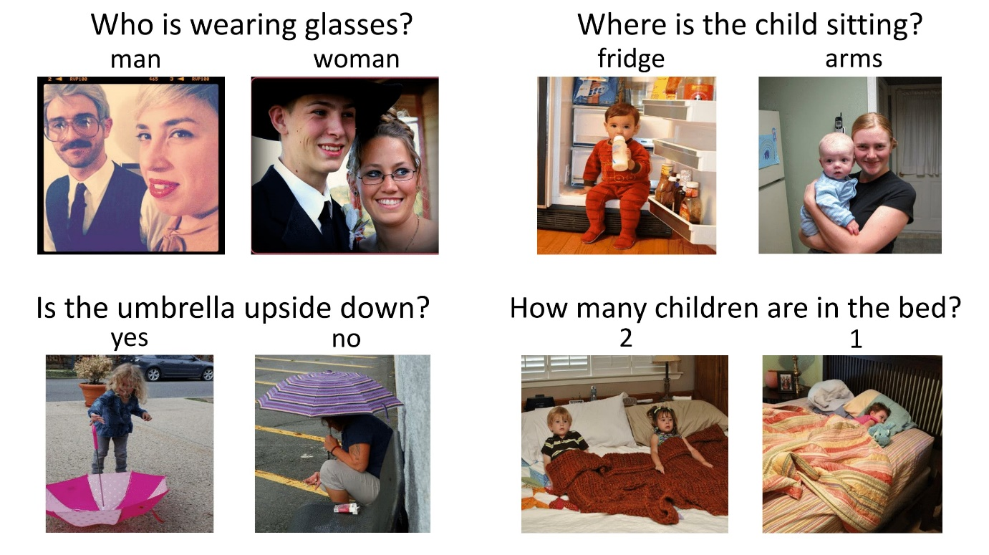

**Dataset Link: -**

[**https://visualqa.org/vqa_v1_download.html**](https://visualqa.org/vqa_v1_download.html)

**Task: -** Create a Web Application using Flask. Use the end user should be able to upload an image and ask questions and get the answers.

**Deployment: -** Any Free Platform(Try to look out for free options.)

**Assignment Submission: -** Only submit the hosted app link. OR GitHub Link

**Practical Assignment**

**Objective: - Human Counting**

A camera can be used to monitor and count the number of people present in the room, building, street, etc.

First, you need to detect people and then we count their occurrence. It is useful to control the crowd.

**Dataset Link: -**

Use anyone of your choice.

**Task: -** Create a Web Application using FASTAPI. Use the end user should be able to upload an image or video and get results with the count of persons.

**Deployment: -** Any Free Platform(Try to look out for free options.)

**Assignment Submission: -** Only submit the hosted app link. OR GitHub Link

**Practical Assignment**

**Objective: - Blur the Face**

Blurring the face area of people from videos is done in all news channels and to hide the identity of a person.

With computer vision, You can automatically detect the face region of the person and use it to blur the image.

The project will be useful in blurring the faces of the people in the video.

**Dataset Link: -**

Use anyone of your choice.

**Task: -** Create a Desktop App where the user can upload an video and the faces will be blurred.

**Deployment: -** Any Free Platform(Try to look out for free options.)

**Assignment Submission: -** Only submit the hosted app link. OR GitHub Link

**Practical Assignment**

**Objective: - Hand Gesture Recognition**

In this project, you are going to determine the gesture of the hand in real-time using a webcam.

First, the background is separated from the hand region and then the fingers are segmented to predict hand gestures.

With different hand gestures, you can perform different actions.

**Dataset Link: -**

Use anyone of your choice.

**Task: -** Create a Desktop App for real time detection where the user can show hand gestures and identify them.

**Deployment: -** Any Free Platform(Try to look out for free options.)

**Assignment Submission: -** Only submit the hosted app link. OR GitHub Link

**Practical Assignment**

**Objective: - Vehicle Counting and Classification**

You can use the computer vision techniques to classify vehicles on the road, HMV(heavy motor vehicle) or LMV( light motor vehicle) and also count the number of vehicles that travel through a road.

The data can be stored to analyze the different vehicles that travel from a road.

**Dataset Link: -**

Use anyone of your choice.

**Task: -** Create a Desktop App for videos where we can count and classify the vehicles.

**Deployment: -** Any Free Platform(Try to look out for free options.)

**Assignment Submission: -** Only submit the hosted app link. OR GitHub Link

**Practical Assignment**

**Objective: - Receipt Scanner**

Receipt scanners are used everywhere and they store the contents of the bill or receipts.

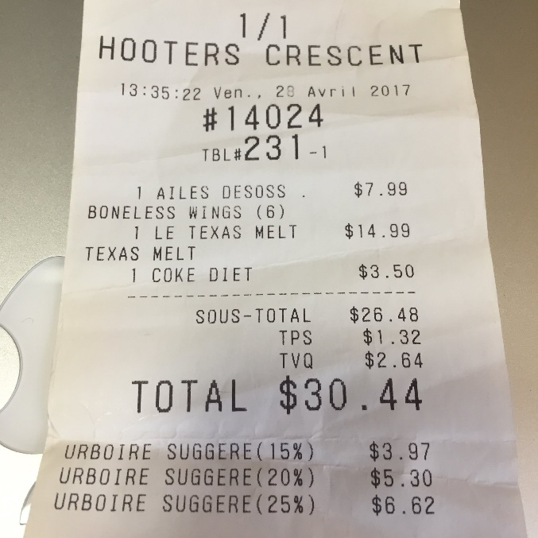

**Dataset Link: -**

Use anyone of your choice.

Ex:- <https://www.kaggle.com/rahulsah06/data-extraction-from-receipt>

**Task: -** Create a Web App where you can user can upload a receipt and get the contents of the receipt.

**Deployment: -** Any Free Platform(Try to look out for free options.)

**Assignment Submission: -** Only submit the hosted app link. OR GitHub Link

**Practical Assignment**

**Objective: - Object Tracking for any objects.**

Object tracking is the process of identifying where a particular object is present in the image.

Library :- https://github.com/tryolabs/norfair

**Dataset Link: -**

Use anyone of your choice.

**Use any 2 object for Tracking.**

**Task: -** Create a Desktop App where the videos can be used and get the count of 2 objects in the video.

**Deployment: -** Any Free Platform(Try to look out for free options.)

**Assignment Submission: -** Only submit the hosted app link. OR GitHub Link

**Practical Assignment**

**Objective: - Image Super-Resolution**

Image Super Resolution refers to the task of enhancing the resolution of an image from low-resolution (LR) to high (HR).

Deep learning techniques have been fairly successful in solving the problem of image and video super-resolution

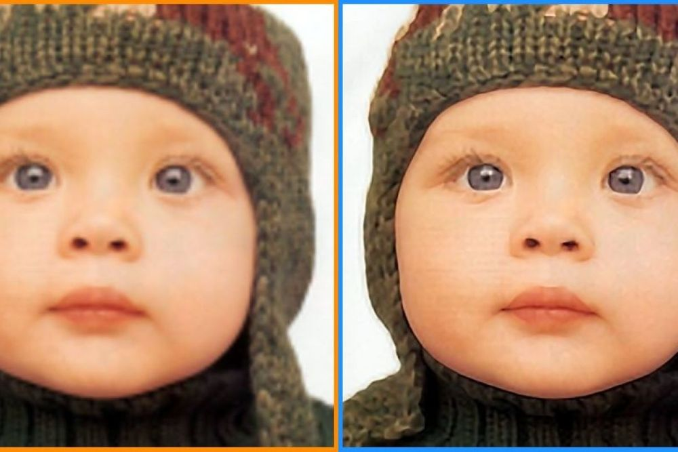

**Dataset Link: -**

Use anyone of your choice.

**Task: -** Create a Web Application using FASTAPI. Use the end user should be able to upload an image and get results with the prediction.

**Deployment: -** Any Free Platform(Try to look out for free options.)

**Assignment Submission: -** Only submit the hosted app link. OR GitHub Link